Jaime’s

**Description of how Lock should function.**

**Stand Bye Mode:**

In this mode solenoid will not be retracted (no power), Leds will be off and controller will be awaiting button press.

**General Operation:**

* Person approaches lock
* Press button, led will begin to blink red indicating lock is listening for a knock, this operation will last a duration of 5 seconds. If no knock is detected or knock is incorrect; nothing happens, led turns off and lock returns to standby mode.
* If knock successful, red led blinking turns off and green led blinks for 2 seconds. Solenoid will also retract for 5-second duration and lock will then return to standby mode.

**Programming Operation:**

* Person approaches lock
* Press button 3 times repeatedly or hold for certain duration whatever the case something to differentiate from a normal press.
* Led will begin blinking red because of button press and turn solid red when lock recognizes it has entered program mode. This operation will last a duration of 5 seconds. If no knock is detected or knock is incorrect; nothing happens, led turns off and returns to standby mode.
* If knock is correct, green led will blink on once confirming current knock and return to solid red, prompting for new knock this will last for 5-seconds and end in a green led flash. The red will turn on one last time to confirm new knock, this will last a duration of 5 seconds, If no knocks are detected or new knocks don’t match; nothing happens, led turns off, old knock is kept and returns to standby mode.
* If current knock is correct, and new knock is confirmed led flashes green for a 3 second duration and then returns to stand bye mode.

**First Time operation:**

* Person approaches lock
* Press button, led will begin to blink red and green indicating there is no knock saved this operation will last 5-seconds and turn solid red indicating it is listening for a knock, this operation will last a duration of 5 seconds and then blink green and return to red asking to confirm this knock. If no knocks are detected or knocks do not match; nothing happens, led turns off and returns to standby mode with no knock saved.
* If knocks match led will blink green, knock is stored; solenoid will retract for 5-seconds and return to stand-bye mode.

*** note “First Time Mode” should only be entered if no knock is saved or reset button is pressed.

We can also use the Piezo as a buzzer to indicate incorrect knock.

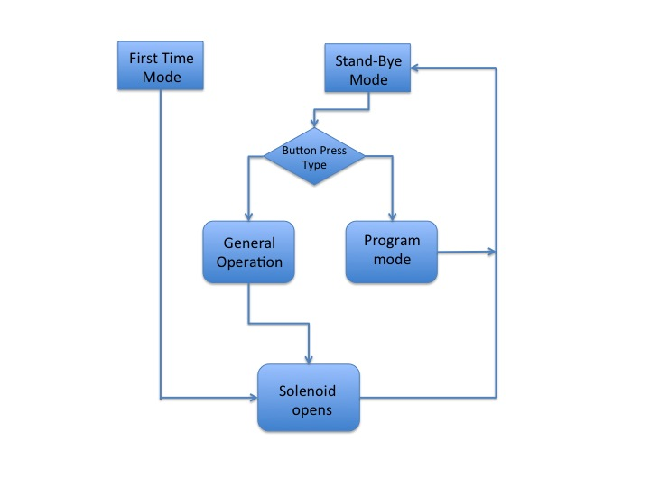

Fig. 1 Flow Chart of nocLock algorithm